**Sky Sights Charter Company**

**Created by: Jonathan Cross, Thomas Thompson, Jasin Gettel, Hunter Haapala**

**Abstract:**Sky Sights’ scope is high, set in the clouds of problems plaguing a modern, disconnected charter company. A company these days that doesn’t have a digital database can suffer greatly, and a charter company is no exception. Keeping up to date with employees, along with their licenses and certifications, was once possible through physical logs, but with this charter company needing to keep track of their employees’ tests, renewals, and the company itself having to keep track of the license/certification renewals it personally does, the use of a digital database saves time and money. Not to mention, employees could meet the requirements for other jobs on different flights, so the database helps keep a tighter log on which employee is for which job, and then checks if the employee meets those requirements. Other important aspects, like the # of the charter vehicle being used, along with all the factors in play, can be easily catalogued and monitored through the database! And of course, keeping an eye on customers, having a set account for them, along with setting a balance and any special requirements the customer may need the company to accommodate for. A charter company like this one needs a database system to keep everything in check, and allow them to grow into an amazing company, and that is exactly what Sky Sights aims to do!

**True Abstract:**

* This report will outline the creation and implementation of a database that supports and holds the data of a Charter Company. This database will keep track of employee and customer information, it will also have a separate entity that holds that data of specific employee test results, and dates.

Creating a database to keep track of employees and their certifications / licenses as well as testing dates and codes. Quality control within a team of employees. Codes apply to the employee’s identity and tests.

There are extra aspects, loadmasters and flight attendants.  *

**Attributes**

EMP_CODE - Employee Code - INT

EMP_FNAME - Employee First Name - STRING

EMP_LNAME- Employee Last Name - STRING

INSTRU_RATING - Instrument Rating - INT

MEL - Multi Engine Land Aircraft Rating - FLOAT

LM -Loadmaster - STRING   
FA - Flight Attendant - STRING

CERT - Certification Type - STRING

LIC - License Type - STRING

LIC_DATE - License Earned - DATE

CERT_DESC - STRING

CERT_DATE - Certification Data Earned - DATE

TEST_CODE - Test Code - INT

TEST_DESC - STRING

TEST_LAST_TEST_DONE - DATE

TEST_NEXT_TEST_DUE - DATE

TEST_RSLT - STRING

**Entities**

* **Employees**
  + EMP_CODE
  + EMP_FNAME
  + EMP_LNAME  
    CERT or LIC

-  **Results**

- TEST_CODE - Test Code - INT

- TEST_DESC - STRING

- TEST_LAST_TEST_DONE - DATE

- TEST_NEXT_TEST_DUE - DATE

- TEST_RSLT - STRING

* **CHARTER TRIP**
* CHARTER_NUM
* PILOT_CODE
* CHARTER_TRIP_LENGTH
* CHARTER_COSTS
* CHARTER_REVENUE

* **CUSTOMER**
* CUS_ACCOUNT_NUM
* CUS_BALANCE_DUE
* CUS_REQ

BUSINESS RULES:

* A customer may request many charter trips
* Each charter trip is request by only one customer
* Some customers have not yet requested a charter trip
* An employee may be assigned to serve as a crew member on many charter trips.
* Each charter trip trip may have many employees assigned as crew members
* Charter flights take place to only after a customer reserves the use of an aircraft at a designated date and time to fly to one or more designated areas
* Customers may pay the bills or charge it to their accounts
* Customers may not charge an amount that exceeds the available credit
* A crew may consist of one or more persons, and not all crew members are pilots
* Pilots are required to generate a record for each charter trip
* All employees are required to complete proper training, pass tests, and receive the correct licenses and certifications.
* Employees are not restricted to one crew member certification.
* A monthly summary of all charter trips, revenues, and expenses is generated from the charter records

Data Dictionary:

|  |  |  |  |  |  |  |  |  |
| --- | --- | --- | --- | --- | --- | --- | --- | --- |
| Table Name | Attribute Name | Contents | Type | Format | Range | Required | PK or FK | FK Reinforced Table |
| **Employee** | EMP_CODE | Employee’s account code | INT | 9999 | 1000-9999 | Y | PK |  |
|  | EMP_FNAME | Employee’s first name | STRING | Xxxxx |  | Y |  |  |
|  | EMP_LNAME | Employee’s last name | STRING | Xxxxx |  | Y |  |  |
|  | CERT | Employee’s license/ Certification | STRING | xxxxxx |  | Y |  |  |
| **Results** | TEST_CODE | Test Employee Code | INT | 9999 | 1000-9999 | N | FK | Employee |
|  | TEST_DESC | Test Description | STRING |  |  | N |  |  |
|  | TEST_LAST_TEST_DONE | Test of last test finished by Employee | STRING | xxxxx |  | Y | FK | Employee |
|  | TEST_NEXT_TEST_DATE | Date of next test to be finished by employee | STRING | xxxxxx |  | Y | FK | Employee |
|  | TEST_RSLT | Test results of Employee | STRING | xxxxx |  | Y |  |  |
| **Charter Trip** | CHARTER_NUM | Number code of Charter trip | INT | 9999 | 1000-9999 | Y |  |  |
|  | PILOT_CODE | Pilot code | INT | 9999 | 1000-9999 | Y |  |  |
|  | CHARTER_TRIP_LENGTH | The length of the charter trip. | TIME | 9:99 | 0:00-999:999 | Y |  |  |
|  | CHARTER_COSTS | The cost of a charter trip | MONEY | $9999.99 | $0.0 - 9999.99 | Y |  |  |
|  | CHARTER_REVENUE | Revenue achieved by charters. | MONEY | $9999.99 | $0.0 - 9999.99 | Y |  |  |
| **Customer** | CUS_ACCOUNT_NUM | A customer’s account number/code | INT | 9999 | 1000-9999 | Y |  |  |
|  | CUS_BALANCE_DUE | A customer’s balance due | MONEY | $9999.99 | $0.0-9999.99 | Y |  |  |
|  | CUS_REQ | A customer’s special requirement(s) | STRING | xxxxx |  | N |  |  |

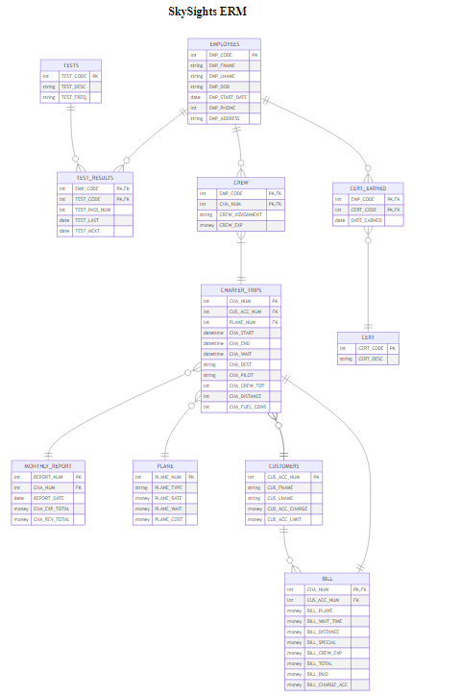

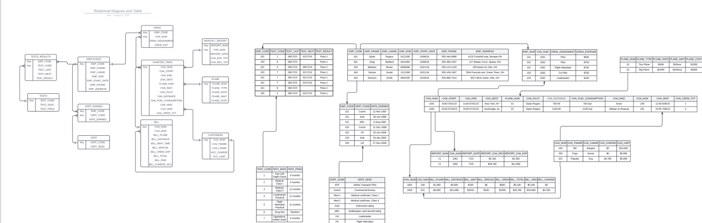

A text view of our SQL code used for MySQL.

/* Database Systems, Coronel/Morris */

/* Type of SQL : MySQL */

CREATE DATABASE IF NOT EXISTS final;

USE final;

CREATE TABLE EMPLOYEES (

EMP_CODE INT PRIMARY KEY,

EMP_FNAME TEXT,

EMP_LNAME TEXT,

EMP_DOB TEXT,

EMP_START_DATE DATE,

EMP_PHONE INT,

EMP_ADDRESS TEXT

)

ENGINE = INNODB;

CREATE TABLE CUSTOMERS (

CUS_ACC_NUM INT PRIMARY KEY,

CUS_FNAME TEXT,

CUS_LNAME TEXT,

CUS_ACC_CHARGE DECIMAL(10, 2),

CUS_ACC_LIMIT DECIMAL(10, 2)

)

ENGINE = INNODB;

CREATE TABLE PLANE (

PLANE_NUM INT PRIMARY KEY,

PLANE_TYPE TEXT,

PLANE_RATE TEXT,

PLANE_WAIT DECIMAL(10, 2),

PLANE_COST DECIMAL(10, 2)

)

ENGINE = INNODB;

CREATE TABLE CHARTER_TRIPS (

CHA_NUM INT PRIMARY KEY,

EMP_CODE INT,

CUS_ACC_NUM INT,

PLANE_NUM INT,

CHA_START TIME,

CHA_END TIME,

CHA_DEST TEXT,

CHA_PILOT TEXT,

CHA_CREW_TOT INT,

CHA_DISTANCE INT,

CHA_FUEL_CONS INT,

CHA_WAIT DECIMAL(10, 2),

FOREIGN KEY (EMP_CODE) REFERENCES EMPLOYEES(EMP_CODE),

FOREIGN KEY (CUS_ACC_NUM) REFERENCES CUSTOMERS(CUS_ACC_NUM),

FOREIGN KEY (PLANE_NUM) REFERENCES PLANE(PLANE_NUM)

)

ENGINE = INNODB;

CREATE TABLE TESTS (

TEST_CODE INT PRIMARY KEY,

TEST_DESC TEXT,

TEST_FREQ TEXT

)

ENGINE = INNODB;

CREATE TABLE TEST_RESULTS (

EMP_CODE INT,

TEST_CODE INT,

TEST_PASS_NUM INT,

TEST_LAST DATE,

TEST_NEXT DATE,

PRIMARY KEY (EMP_CODE, TEST_CODE),

FOREIGN KEY (EMP_CODE) REFERENCES EMPLOYEES(EMP_CODE),

FOREIGN KEY (TEST_CODE) REFERENCES TESTS(TEST_CODE)

)

ENGINE = INNODB;

CREATE TABLE CERT (

CERT_CODE INT PRIMARY KEY,

CERT_DESC TEXT

)

ENGINE = INNODB;

CREATE TABLE CERT_EARNED (

EMP_CODE INT,

CERT_CODE INT,

DATE_EARNED DATE,

PRIMARY KEY (EMP_CODE, CERT_CODE),

FOREIGN KEY (EMP_CODE) REFERENCES EMPLOYEES(EMP_CODE),

FOREIGN KEY (CERT_CODE) REFERENCES CERT(CERT_CODE)

)

ENGINE = INNODB;

CREATE TABLE CREW (

EMP_CODE INT,

CHA_NUM INT,

CREW_ASSIGNMENT TEXT,

CREW_EXP DECIMAL(10, 2),

PRIMARY KEY (EMP_CODE, CHA_NUM),

FOREIGN KEY (EMP_CODE) REFERENCES EMPLOYEES(EMP_CODE),

FOREIGN KEY (CHA_NUM) REFERENCES CHARTER_TRIPS(CHA_NUM)

)

ENGINE = INNODB;

CREATE TABLE MONTHLY_REPORT (

REPORT_NUM INT PRIMARY KEY,

CHA_NUM INT,

REPORT_DATE DATE,

CHA_EXP_TOTAL DECIMAL(10, 2),

CHA_REV_TOTAL DECIMAL(10, 2),

FOREIGN KEY (CHA_NUM) REFERENCES CHARTER_TRIPS(CHA_NUM)

)

ENGINE = INNODB;

CREATE TABLE BILL (

CHA_NUM INT PRIMARY KEY,

CUS_ACC_NUM INT,

BILL_PLANE TEXT,

BILL_WAIT_TIME TIME,

BILL_DISTANCE INT,

BILL_SPECIAL TEXT,

BILL_CREW_EXP DECIMAL(10, 2),

BILL_TOTAL DECIMAL(10, 2),

BILL_PAID DECIMAL(10, 2),

BILL_CHARGE_ACC DECIMAL(10, 2),

FOREIGN KEY (CHA_NUM) REFERENCES CHARTER_TRIPS(CHA_NUM),

FOREIGN KEY (CUS_ACC_NUM) REFERENCES CHARTER_TRIPS(CUS_ACC_NUM)

)

ENGINE = INNODB;

Screenshot of our SQL/PHP tables during a search:

